Non relational database management system is called a NoSQL database.

Non relational database is a database that doesn’t use tabular schema of row and column.

* Document store semi-structured data as document, typically in JSON or XML format.
* MongoDb is better than mysql database.

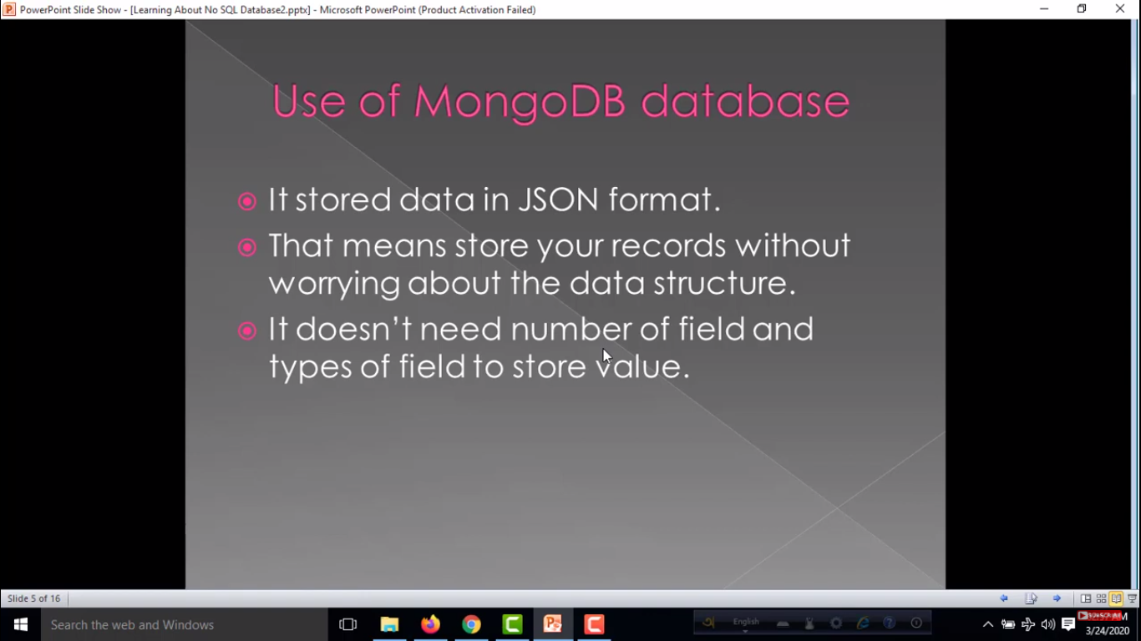 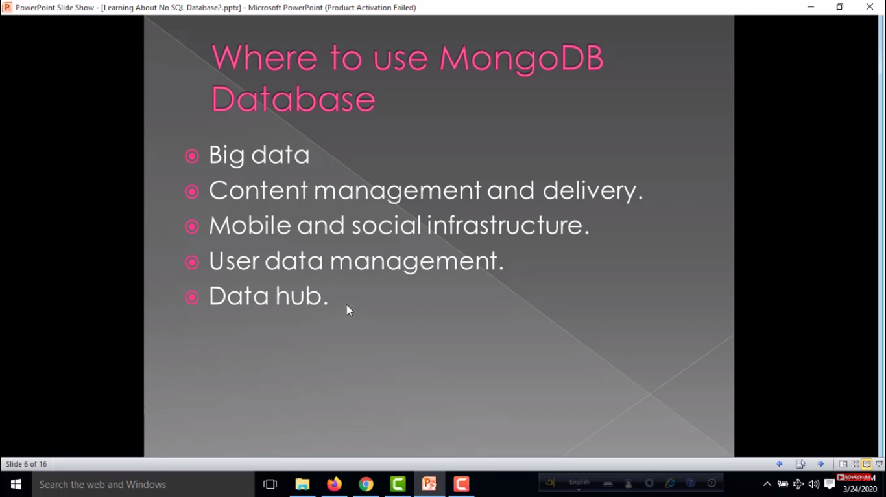

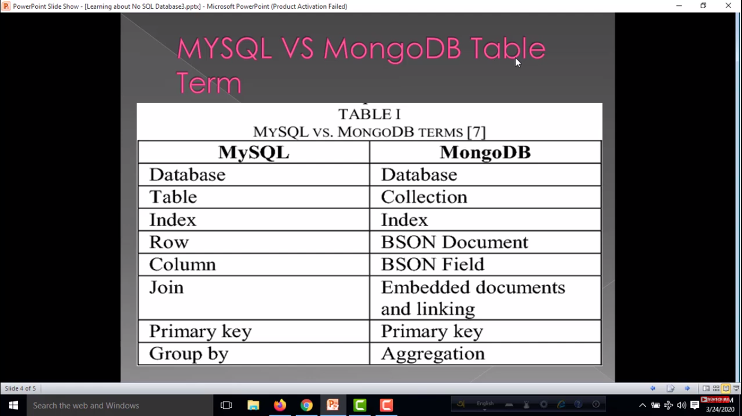

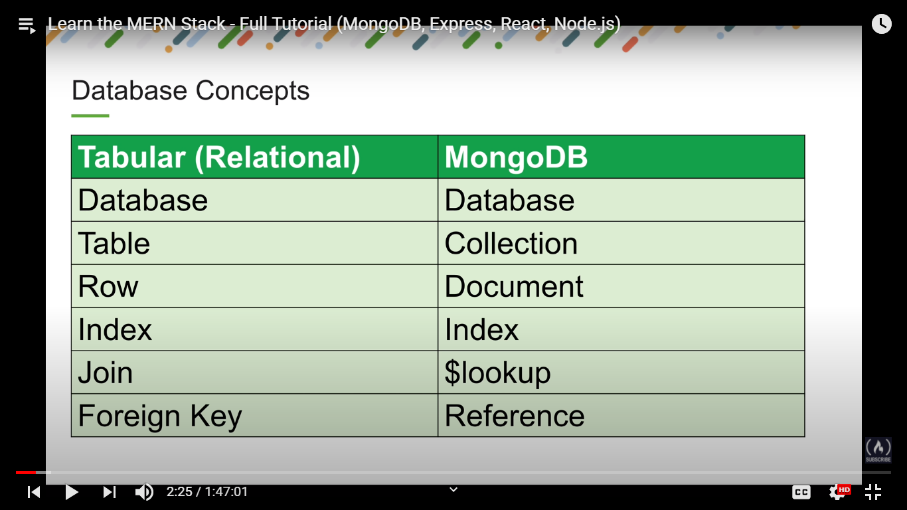

'once' it signifies that the event will be called only once.

'on' signifies the event will be called every time that it occurred

For mongodb connection:

Command: mongod

For check transaction Command:

show dbs

db => Type db to display the current database.

use test => you can access test database //here also create test db

show collections

db.testsAll.find() => you can find all data from testsAll Collections.